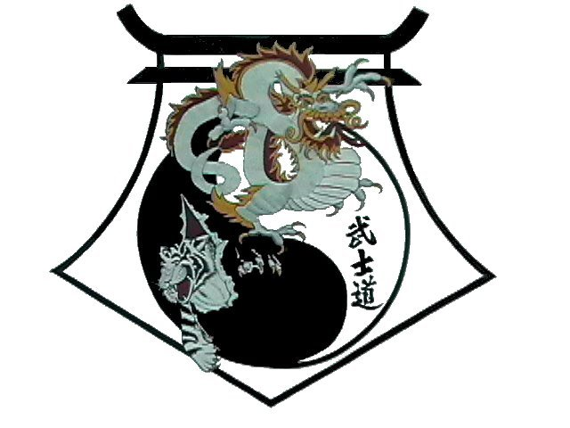
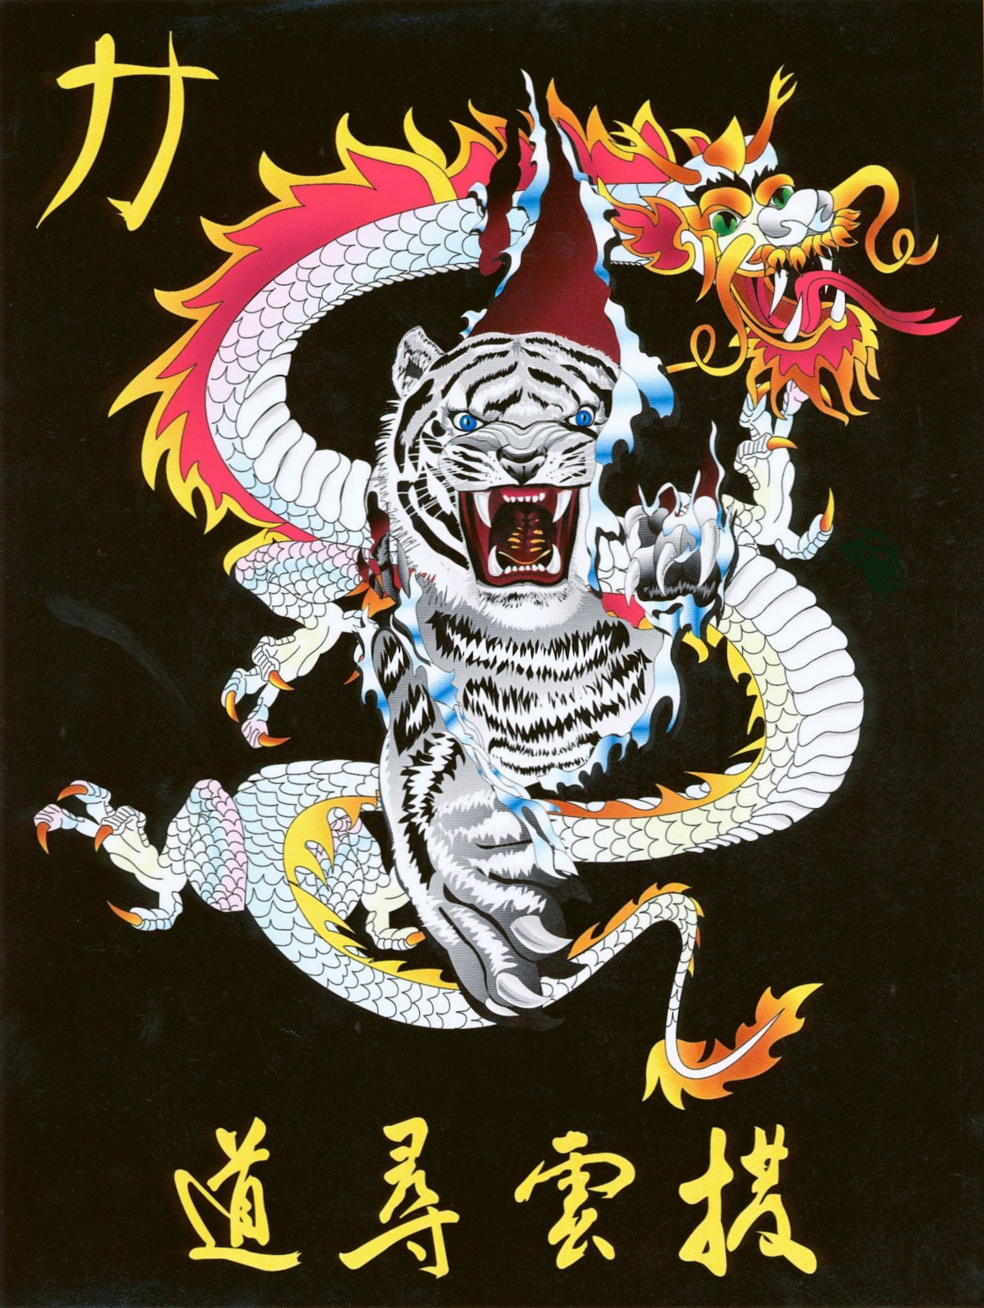
Shihan Ron Bennett’s
White Dragons of Bushido
Won Hyo
Bow
1. | Step to Left Back Stance to 9 oclock and C-Block.
2. | Right Shuto Strike.
3. | Left Punch.
4. | Step to Right Back Stance to 3 oclock and C-Block.
5. | Left Shuto Strike.
6. | Right Punch.
7. | Step Right to Left Foot, Chamber on right.
8. | Left Side Kick to 12 oclock.
9. | Land in Left Check to 12 oclock.
10. | Right Check to 12 oclock.
11. | Left Check to 12 oclock.
12. | Step to Right Forward Stance and Spear Hand.
13. | Step to Left Back Stance to 3 oclock, C-Block.
14. | Right Shuto Strike.
15. | Left Punch.
16. | Step to Right Back Stance to 3 oclock and C-Block.
17. | Left Shuto Strike.
18. | Right Punch.
19. | Step to Left Forward Stance to 6 oclock.  Right Circular Block.
20. | Right Front Kick.
21. | Land in Right Forward Stance.  Left Punch.
22. | Left Circular Block.
23. | Left Front Kick.
24. | Land in Left Forward Stance.  Right Punch.
25. | Step Right to Left Foot, Chamber on left.
26. | Right Side Kick to 6 oclock.
27. | Step to Left Back Stance to 9 oclock, Left Outward Block.
28. | Shuffle Step to Right Back Stance to 3 oclock, Right Outward Block and KIAI
Bow
Shihan Ron Bennett’s
White Dragons of Bushido
Won Hyo
This pattern is named for the Buddhist monk Won-Hyo (617-686 A.D.), who is credited with having completed the introduction of Buddhism to the general population of the kingdom of Silla just prior to his death.
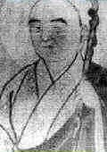
The pattern consists of 28 movements and is named for the Buddhist monk Won-Hyo (617-686 A.D.), who is credited with having completed the introduction of Buddhism to the general population of the kingdom of Silla just prior to his death.
Won-Hyo, born in northern Kyongsang Province, was said to be wise from birth. As legend has it, he was born in a forest in Chestnut Valley under a Sal tree. The Sal tree is significant, as reference to it is usually only found in the legends of very revered figures.
Won-Hyo's official name, given to him at birth, was Sol Sedang. He derived the pen name Won-Hyo, meaning "dawn," from his nickname "Sedak," which had the same meaning. He assumed this pen name in later years after he had become more accomplished as a Buddhist philosopher and poet. In the past Koreans were identified by many names: each person had a nickname as well as an official name. A person of intellectual or artistic talents might also be given a pen name, and monks and apprentices were often given yet another name by their masters.
Won-Hyo started his career at the age of 20 when he decided to enter the Buddhist priesthood and converted his own home into a temple. Buddhism, however, was not a popular religion in Silla at that time. Although this religion had been introduced into the kingdom of Koguryo in 372 A.D. and Paekche in 384 A.D., the general population of Silla was reluctant to accept it. The monk A-Tow was supposed to have introduced it to Silla between 417 A.D. and 457 A.D., but the religion was mainly confined to the royal family and rejected by the people.
This religious isolation, however, was to change during the 7th century. At that time (Palguk -Sa Templet folket). Silla was at war with the kingdoms of Packche and Koguryo. It was under constant invasion from Paekche and, in the year 642 A.D., it lost 40 castles to Packche attacks, including the great castle of Taeya near the capital of Silla. This atmosphere dramatically influenced the Buddhist faith of all three kingdoms. Religion became more nationalistic, which tended to intensify the ferocity of the conflicts.
In order to accelerate the development of this type of national spirit in Silla, King Pop-Hung wanted to officially recognize Buddhism in 527 A.D. He tried to establish it as an official state religion in the area around Kyongju. The attempt was met with vehement opposition by members of ever, in 528 A.D., these members of the court pressured the King into agreeing to the execution of a 22year old monk named Ichadon to convince them the Buddhism was worthwhile religion. Ichadon's death for his belief in Buddhism resulted in stories of his blood at the execution being white as milk. These stories made him a martyr to King issued a royal mandate that granted freedom of Buddhist belief. Shortly afterward, Buddhism was accepted by the people. Ichadon was named as one of the ten sacred monks of Silla, by King Hun-Duk in later years, but the study of Buddhism during the reign of King Pop-Hung required the ability to read and write Chinese. Therefore, serious study was still confined mainly to the monks and the aristocratic population.

Unfortunately, not many places were open for the serious Buddhist student to study in Silla. Therefore, Won-Hyo and the noted monk Ui Sang, like other monks of the time, set out to study Buddhism in China in 650 A.D. The overland journey took them to Liaotung in Koguryo. Mistaken as spies along the way by several Koguryo sentries, they barely escaped captivity and revere able to return to Silla. There is no further record of Won-Hyo traveling to China to study although vie more attempt was made shortly after Packche was defeated in 660 A.D. by Silla and Tang troops from China. Such study was not necessary however, because wisdom was Won-Hyo's from birth and he did not need a teacher. He therefore became the only monk of his time Chin did not study in China
The many monks who did study in China had a broad impact on the religious culture of the Korean peninsula. In fact, there were at least five main sects of Buddhism being practiced in Silla during this period Kyeyul, Yulban, Chinpyo, Popsong, and Hwaom. Chinpyo and Popsong were introduced by Won-Hyo with Popsong, being based Hwajong-non (Treatise on the Harmonious Understanding of the Ten Doctrines) from which Won-Hyo's posthumous title of "Hwajong Kuksa" was derived. Won-Hyo was, in fact, the most influential of the many monks of the 7th century. He used his power in an attempt to unify the five existing sects and reduce their constant sectarian rivalries. He is also considered as one of the most prolific writers in al I of the Buddhist countries of his time: his works include over 100 different kinds of literature consisting of about 240 volumes. Unfortunately, only 20 works within a total of 25 volumes have survived. One of the forms he chose to use was a special Silla poetic form, Hyang-Ga, These poems were mainly written by monks or members of the Hwarang and concerned patriotism, Buddhism, and praise of the illustrious dead. Won Hyo's poem "Hwaorm-Ga" is said to be among the most admired of these poems.
Won-Hyo's writing was not the only area in which he gained recognition. He was well-known both to the general population and to the members of the royal family and their court. He was often asked to conduct services, recite prayers, and give sermons at the royal court. In 660 A.D., King Muyo became so interested in Won-Hyo that he asked him to come and live in the royal palace of Yosok. A relationship with the royal princess Kwa developed and was soon followed by their marriage and the birth of their son Sol-Chong.
Sol-Chong grew up to become one of the ten Confucian sages of the Silla era. He is recognized for his scholarship in Chinese literature and history, and for his adaptation of Idu, the system of using Chinese characters phonetically to record Korean songs and poems. As Korea had not yet developed an alphabet this adaptation was very important It made Chinese literature available to the general public by creating, in effect, a method for translation. Sol-Chong is said to have been the author of many original works; however his Kye-Hwa-Wang is his only surviving work.
Shortly after his son was born Won-Hyo left the palace and began traveling the country. In 661 A.D. he experienced a revelation in his Buddhist philosophy and developed the Chongto-Gyo (Pure Land) sect. This sect did not require study of the Chinese Buddhist literature for salvation, but merely diligent prayer. His belief was that one could obtain salvation, or enter the "Pure L and", by simply praying. This fundamental change in Buddhist philosophy made religion accessible to the lower classes. It soon became very popular among the entire population. And, in 662 A.D., Won-Hyo left the priesthood and devoted the rest of his life to traveling the country teaching this new sect to the common people.
Won-Hyo's contributions to the culture and national awareness of Silla were instrumental in the unification of the three kingdoms of Korea. By 660 A.D. Packche the allied armies of Silla and the Tang Dynasty of China. T. Later, in 668 A.D., the king of Silla, Moon-Moo was finally successful in defeating the kingdom of Koguryo. This victory was tainted, however, when the Tang troops set their goals on also conquering Silla But, in 677 A.D., after nine years of resistance, the Tang armies were driven from Korea and the unification of the three Kingdoms of Korea was completed.
Won-Hyo died in 686 A.D. and was laid in state by his son Sol-Chong in Punhwang-Sa temple. I He had seen the unification of the Three Kingdoms of Korea in his own lifetime and had helped to bring about a brilliant culture in Korea through his efforts in Buddhist philosophy. He had a profound influence on quality of life in Silla and on Buddhism in Korea, China, and Japan.

