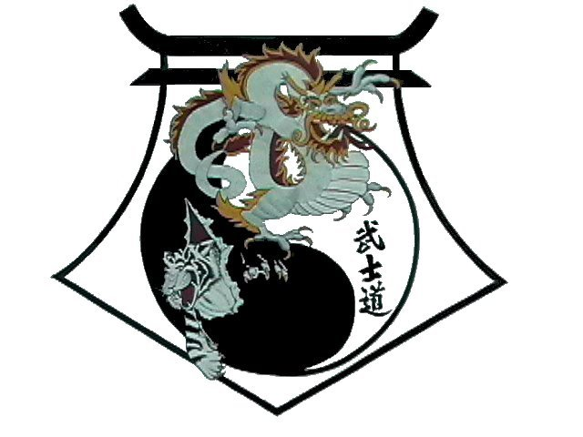
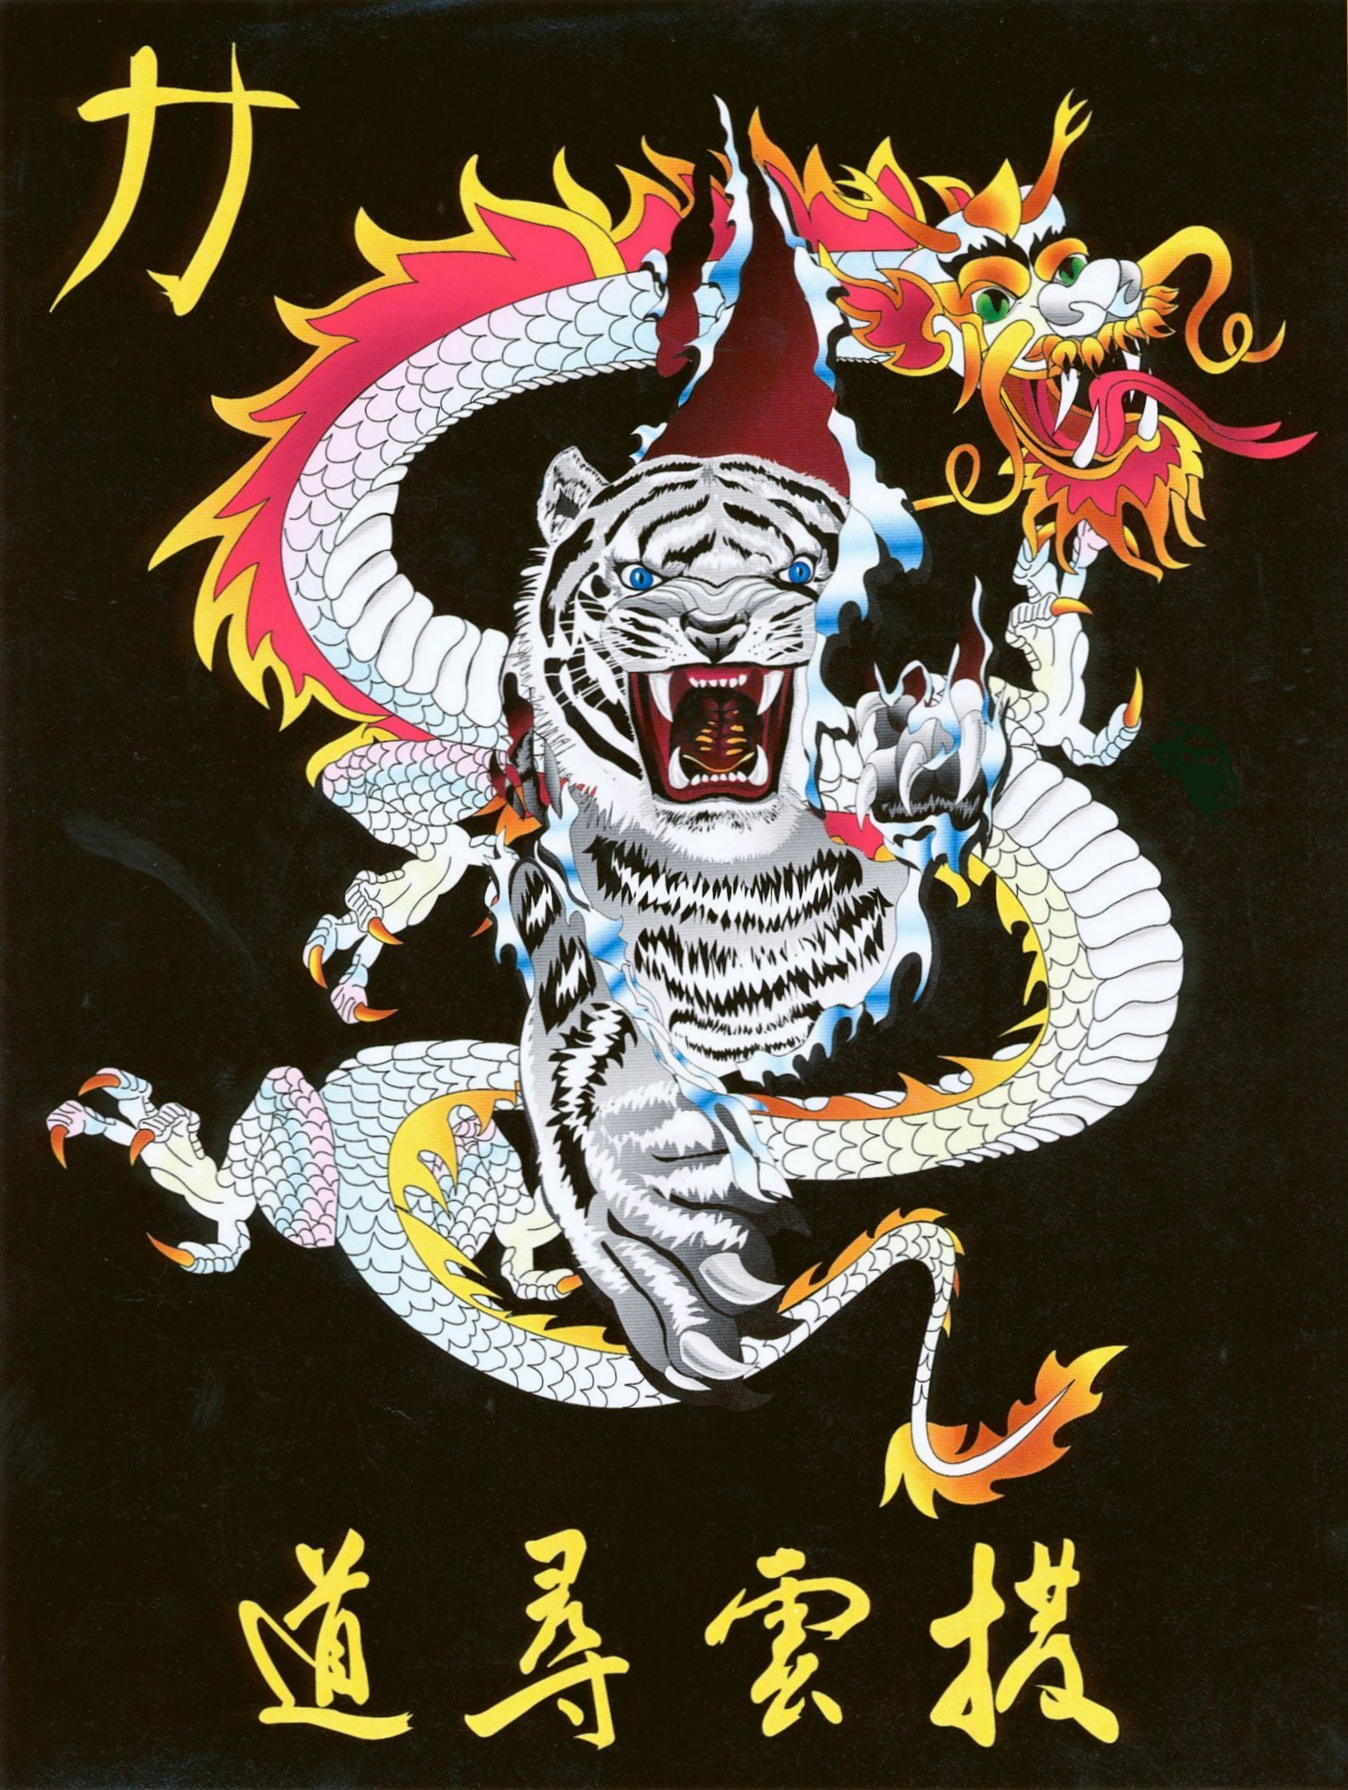
Shihan Ron Bennett’s
White Dragons of Bushido
Toi Gye

Bow
1. Step to Left Back Stance to 9 oclock, Left Outward Block.
2. Shift to Left Forward Stance, Right Spear Hand.
3. Step Left Foot to Right Foot, Right High Block, Left Low Block.
4. Step to Right Back Stance to 9 oclock, Right Outward Block.
5. Shift to Right Forward Stance, Left Spear Hand.
6. Step Right Foot to Left Foot, Left High Block, Right Low Block.
7. Step to Left Forward Stance to 12 oclock, X-Downward Block.
8. Double Verticle Punch.
9. Right Front Kick.
10. Land in Right Front Stance, Right Punch.
11. Left Punch.
12. Step Right Foot to Left Foot facing 9 oclock.
13. Right Crescent Kick Land in Square Horse facing 6 oclock, W Block.
14. Left Crescent Kick Land in Square Horse facing 12 oclock, W Block.
15. Left Crescent Kick Land in Square Horse facing 6 oclock, W Block.
16. Right Crescent Kick Land in Square Horse facing 12 oclock, W Block.
17. Left Crescent Kick Land in Square Horse facing 6 oclock, W Block.
18. Left Crescent Kick Land in Square Horse facing 12 oclock, W Block.
19. Shift to Left Back Stance, Low Double Forearm Block.
20. Shift to Left Forward Stance, Grab High.
21. Right Knee Strike.
22. Land in Left Back Stance, Left Check, facing 6 oclock.
23. Left Front Kick, Right Spear.
24. Land in Left Forward Stance, Left Spear.
25. Step to Right Back Stance to 6 oclock, Right Check.
26. Right Front Kick, Right Spear.
27. Land in Right Forward Stance, Right Spear.
28. Shift to Left Back Stance, Right High Back Fist, Left Downward Block.
29. Jump to X-Stance facing 3 oclock, X-Downward Block.
30. Step to Right Forward Stance to 6 oclock, Right Reinforced Outward Block.
31. Step to Left Back Stance to 9 oclock, Left Downward Knifehand Block.
32. Shift to Right Forward Stance, Right Circle Block
33. Step to Right Back Stance to 3oclock, Right Downward Knifehand Block.
34. Shift to Left Forward Stance, Left Circle Block.
35. Right Circle Outward Block.
36. Left Circle Outward Block.
37. Step up to Square Horse Stance, Right Punch.
Bow

Shihan Ron Bennett’s
White Dragons of Bushido
Toi Gye
TOI-GYE is the pen name of the noted scholar Yi Hwang (Yi Toi-Gye), who lived from 1501 to 1570. He was also an authority on neo Confucianism. The 37 movements of the pattern refer to his birthplace on 37 latitude, the diagram, or shape, of this Tul + represents the Chinese character for "scholar".
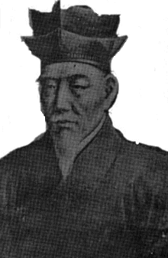
Yi Hwang was born in 1501 in the province of Kyongsang-Do. He was very intelligent: by the age of 34 he had passed his state exam for civil service. Because this exam was usually not older, he was held in high esteem for this accomplishment.
During his youth he acquired the pen name Yi Toi-Gye which means "returning stream". Although he was appointed to several high government offices during his life, he preferred to devote himself primarily to his academic studies. His legacy was his philosophical teachings, and his writings significantly influenced neo-Confucianism.
Chu-Hsi
The foundation of Toi-Gye's school of thought was based on the philosophy of the 12th century Confucian scholar Chu Hsi. Chu Hsi established the concepts of "li" (reason or abstract form) and "chi" (matter or vital force), and proposed that these two concepts were responsible for all human characteristics and the operation of the universe. As he defined the concepts, they are very similar to the concepts of body and soul in Western philosophy and religion. The "li," however, is not totally synonymous with the idea of an individual represents groups or models for each form of existence. Toi-Gye's school of thought supported the concept that the "ii" was the controlling agent in the universe and that the "chi" was a supporting component. Perfecting oneself through the building of good moral character, learning, and reflection was stressed in the practice of the "li" school of thought. Its influence was strongly felt in the Kyongsang area where Yi Toi-Gye was born. The other major school stemming from the philosophy of Chu Hsi was fostered by Yi I, who proposed that the "chi" controlled the "li." This school stressed the importance of education, experience, and practical intellectual activities. Yi Yul-Gok, 35 years younger than Yi Toi-Gye, once visited him and they spent time discussing their philosophies.
Neo-Konfusianismen
The teachings of Yi Toi-Gye not only had appeal to the scholars of his time in Korea but soon attracted many senior government officials as well. Soon, government and political support increased for the formation of schools teaching 'his concepts of the supremacy of practical ethics Yi Toi-Gye took advantage of his considerable influence when he became the head of a private school or shrine (Tosan Sowon) in Kyongsang province in 1557. This shrine had been dedicated by its previous instructor to the honor of a revered scholar who introduced the teachings of Chu Hsi into Korea. It was a combination shrine, private study facility, school, and social gathering point for local scholars. Yi To-Gye used his political ties to get royal patronage for the Sowon because it was also a shrine for a Confucian sage. This patronage, or tax-free status, resulted in an influx of assets in the form of cash, cattle, land, slaves, grain, and books. As a result, this Sowon, and this type of educational system in general, proliferated and became a predominant type of school in the Yi dynasty.

Politically involved
Yi Toi-Gye's leadership in this school of thought pulled him into the political arena. The Yi dynasty was characterized by political and religious reform with frequent conflicts between scholars and officials. As the underlying principle behind these changes, neo-Confucianism began to dominate the state creed and politics of the Yi dynasty. Under this pressure, all of the Korean Buddhist sects were forced to unify into one of two groups, Son (den) or Kyo. Because Buddhism was viewed by strict neo-Confucians as a social evil, all but 18 of the nation's main Buddhist temples were closed. Political differences ultimately became focused or neo-Confucian concepts and their differences rather than on political problems.
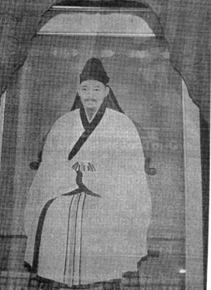
Died in 1570
Although he died in 1570, Yi Toi-Gye, through his teachings, had great historical Impact on Korea during the years that followed. A member of his school of thought, Kim Hyo-Won, occupied a post of considerable power, enabling him to hire, dismiss, or veto all government appointments. When the leader of the opposition party, Sim UP Gyom, arranged to have his brother succeed him, Kim exercised his veto power. This act polarized the entire government. Eventually every official had to become aligned with one side or the other or risk attack by both. Since Kim lived in the eastern quarter of Seoul and Sim lived in the western quarter, the two factions became known as the Easterners and the Westerners The Easterners followed the teachings of Yi Toi-Gye while the Westerners followed the teachings of Yi I This feuding continued long after Kim and Sim had disappeared from public life, and often took the guise of schemes designed to exile members of the rival faction, remove them from office, or get them executed on false charges. Their philosophical differences tended to drive the two factions further apart, increased the conflicts, and made the functioning of government virtually impossible. The day-today functioning of the government and military became so impotent that resistance to the Japanese invasions of Korea by Hideyoshi (200,000-man force) in 1592 and 1597, and the Manchu attacks in 1627 and 1637, were totally ineffective.
Enriching contribution
No doubt Toi-Gye would have been sorely dismayed had he lived to witness the political problems that beset Korea in the name of his teachings. Despite the role it played in that dark chapter of Korea's history, though, Toi-Gye's philosophy has made an enriching contribution to neo-Confucian thought. His influence is still being felt in the 20th century in China, Korea, and Japan.

