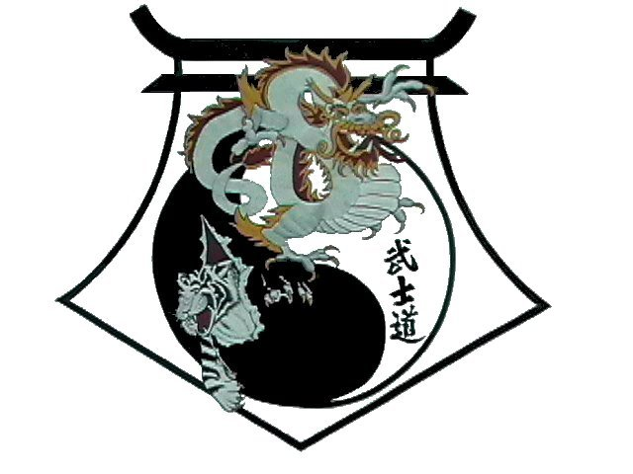
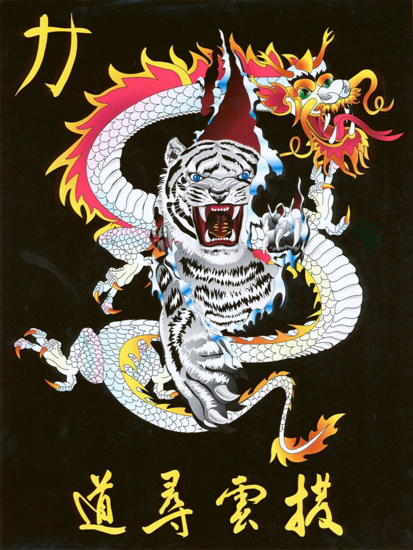
Shihan Ron Bennett’s
White Dragons of Bushido
Chon Ji
Bow
1. | Draw, Left hand to right ear.  Step to Left Forward Stance to 9 oclock, Left Downward Block and KIAI
2. | Lift, step, Right Punch.
3. | Draw, Right hand to left ear.  Step to Right Forward Stance to 3 oclock, Right Downward Block.
4. | Lift, step, Left Punch.
5. | Draw, Left hand to right ear.  Step to Left Forward Stance to 12 oclock, Left Downward Block.
6. | Lift, step, Right Punch.
7. | Draw, Right hand to left ear.  Step to Right Forward Stance to 6 oclock, Right Downward Block.
8. | Lift, step, Left Punch and KIAI
9. | Draw Right hand to left ear.  Step to Left Backstance to 3 oclock and Left Outward Block.
10. | Roll over, step punch.
11. | Draw Left hand to right ear.  Step to Right Backstance to 9 oclock and Right Outward Block.
12. | Roll over, step punch.
13. | Draw Right hand to left ear.  Step to Left Backstance to 6 oclock and Left Outward Block.
14. | Roll over, step punch.
15. | Draw Left hand to right ear.  Step to Right Backstance to 12 oclock and Right Outward Block.
16. | Roller over step punch.
17. | Step forward punch.
18. | Step back and punch.
19. | Step back, punch, KIAI
Bow

Sihan Ron Bennett’s
White Dragons of Bushido
Chon Ji



The word "Chon" in Korean means heaven, and the word "Ji" means earth. The two words combined as "Chon-Ji" can mean universe, creation, or heavenly. Often it is simply interpreted as the creation of the universe. Chon-Ji, "heavenly" lake, is also the name given a large crater lake on Paektu Mountain, an extinct volcano which is said to have been the first residence of the legendary founder of Korea, Dan-Gun. The pattern Chon- Ji is appropriately named because the word creation implies a starting point. Consistent with this name, the pattern establishes a foundation for the martial art of Taekwon-Do. The pattern consists of two similar parts: one part representing heaven and the other earth. The stances and techniques performed as part of this pattern comprise the basic movements required for correct mastery of all 24 patterns.
The serious student appreciates that just as the universe is far more intricate than it may appear, the apparent simplicity of the pattern Chon-Ji masks its true complexity. This pattern holds many hidden lessons that may not be completely realized even after years of dedicated study.

