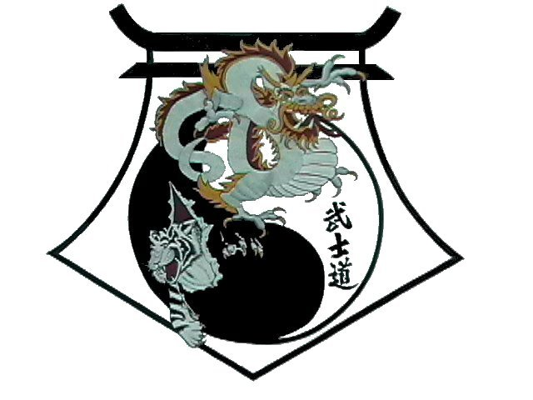
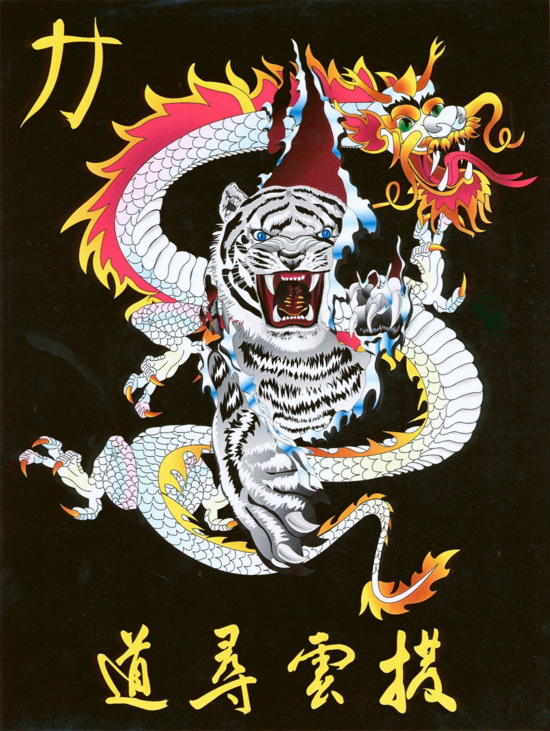
Shihan Ron Bennett’s
White Dragons of Bushido
Joe Souza

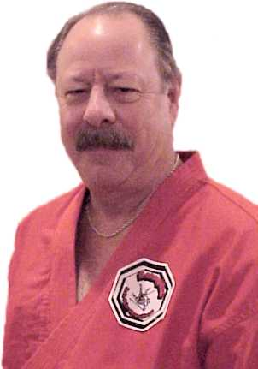
Professor Joe Souza began his martial arts studies in 1957 under the late Professor John Cahill. After his death in 1962, Joe assisted Professor Willy Cahill with opening the Cahill Judo Academy in San Bruno Ca. where it still flourishes as one of the most prominent Judo and Jujitsu Schools in the country.
In 1959 Professor Wally Jay introduced the Cahill Judo Academy to Olympic style judo competition where we became members of the Hoka Yudansha-Kai or Northern California Judo Association. Professor Souza competed for 12 years as an aggressive competitor in Northern California. He received his Shodan from the Kodokan in 1964.
In the early days we were members of the AJJF and later became active with the AJI of Hawaii. Professor Souza received his Nidan in 1967 and Sandan in 1969 from Professor Sam Luke Sr. The AJI was trying to reunite the mainland and Hawaii based association and Professor Luke was the person challenged with this task.
Due to Professor John Cahill passing away at such a young age he had made a special request to his first black belt Professor Bill Montero. He asked Professor Montero to take his senior students and complete the Danzan Ryu system by holding an Okugi. At this request several of us traveled to his dojo in San Jose every Saturday for 3 months to learn Shinyo, Shin Gin and Seifukujutsu along with Kapo and Katsu. Those who attended the 1963 Okugi were Willy Cahill, Fred Cahill, Francis Cahill, Mike Warren, Meg Warren, Clearance “Blackie” Hin, and Joe Souza. Although there were no certificates presented there indeed was a 1963 Okugi.
Professor Souza opened his first dojo in 1964 at the Highland recreation Center in Sam Mateo Ca. In 1965 he began teaching classes for the Pacifica Recreation Department at Oceana and Terra Nova High Schools as well. The recreation department did not support the judo program as promised so Professor Souza along with two of his black belts, Jim Powers and John Antenesia opened Coastside Judo and Jujitsu in Pacifica Ca. where it continued for 12 years.
After some surgery Professor Souza decided to venture out and continue his martial arts training so he began studding Ed Parkers Kenpo Karate from Vinton Koklich. He received his black belt from Professor Koklick in 1997. The addition of Kenpo Karate to his Judo and Jujitsu completed the circle of three disciplines and inspired him to incorporate them into what he calls Kensujitsu. The Ken represents Kenpo Karate; the Ju represents Judo and Jujitsu and the Su represents Souza the founder. The foundation of Kensujitsu is Danzan Ryu Jujitsu with a Small Circle Jujitsu influence. Kensujitsu brings the full understanding of balance from Judo, the high pain compliance, joint manipulation and transitional flow from Jujitsu along with the principles and concepts of American Kenpo Karate to deliver maximum power and efficient use of energy.

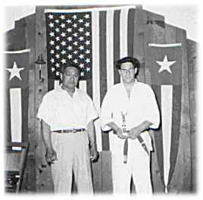
Professor Souza is the founder of Kensujitsu and has been given the title of Sr. Grand Master of Kensujitsu and the rank of Judan 10th Degree from Professor Willy Cahill and Professor Wally Jay. He holds the rank of Shichidan 7th Degree in Jujitsu with Jujitsu America, Sandan 3rd Degree in Judo with the USJA as well as Shodan 1st Degree in
American Kenpo Karate. He was inducted into the Jujitsu America Hall of Fame in 1999, instructor of the year in 2001 and serves as first VP on the board of Jujitsu America, a member of the standards board as well as the Council of Professors. Professor Souza is cofounder and Sr. Grand Master for the Professional Martial Arts Alliance (P.M.A.A.).
Professor Cahill produced a series of videos on the Danzan Ryu system in which Professor Souza participated as a demonstrator as well as an advisor. These videos have been dedicated to Professor Okasaki, Professor John Cahill, and Professor Sig Kufferath. Please contact him via email at joenat1@mindspring.com or by phone at (209) 664-1949.
You may purchase them individually or in 3 formats.
(1) Professor Okazaki Package which includes all 6 tapes.
(2) Professor John Cahill Package, which includes 3 tapes on Yawara, Shime no Kata and Nage no Kata.
(3) Professor Sig Kufferath Package, which includes 3 tapes on Oku no Kata, Shinnin no Maki part 1, and Shinin no Maki part 2.
Tapes may be purchased directly from Professor Joe Souza.

