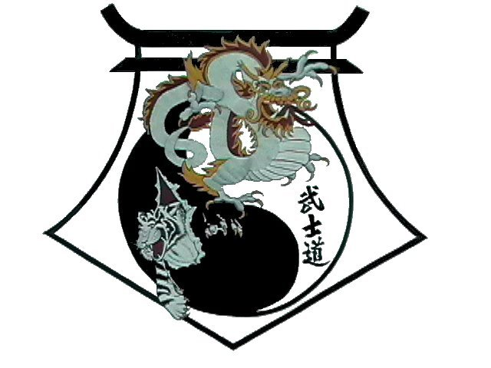
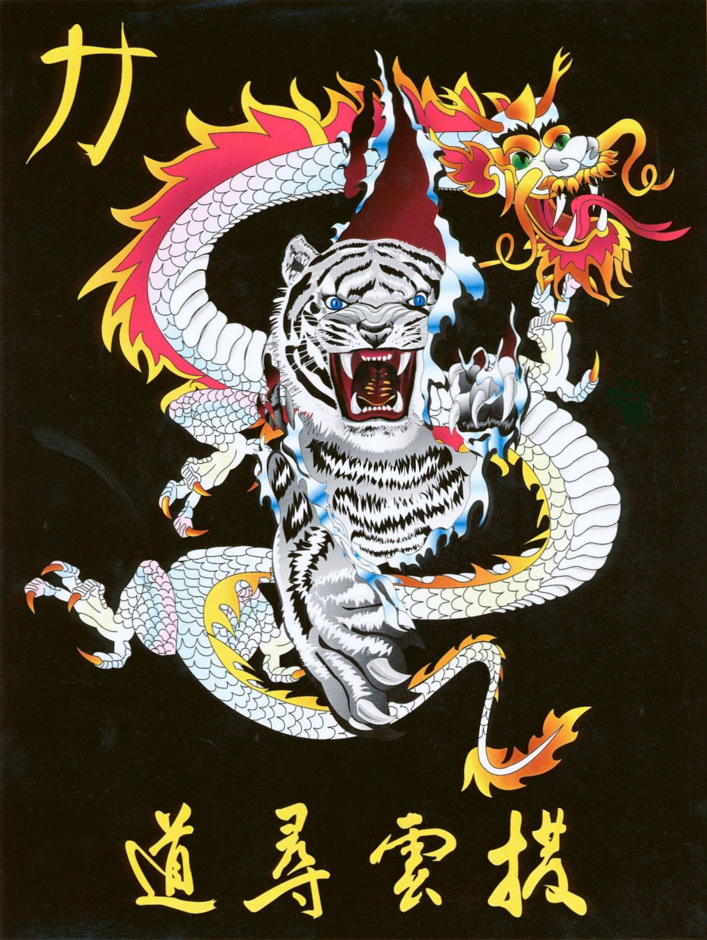
Shihan Ron Bennett’s
White Dragons of Bushido
USA Flag

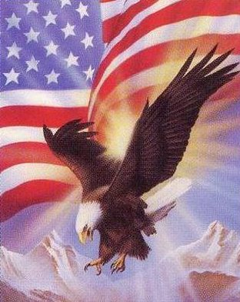

History
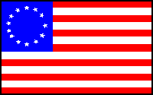
Flags are an important part of countries around the world. They have been potent emblems of national pride, political parties, and revolutionary movements. Canadians debated for several decades whether the nation should have a distinctive flag, and, if so, what its design should be. The debate subsided somewhat after the present national flag was adopted in 1965. A similar discussion took place in South Africa in the 1920s. In South Vietnam in the early 1960s, the refusal of President Ngo Dinh Diem to allow the display of Buddhist flags was a political decision that contributed to his overthrow and assassination. The potential for expressing deep-felt emotions in a condensed, but obvious form, and with great public visibility, has made flags an important medium of political communication in the 20th century.
Surprisingly, the origin of the United States national flag, the Stars and Stripes (also known as the Star-Spangled Banner, the Red, White, and Blue, and Old Glory), is somewhat obscure. The flag was officially adopted on June 14, 1777, when the Continental Congress resolved that "the Flag of the United States be 13 stripes alternate red and white, that the Union be 13 stars white in a blue field representing a new constellation." Its immediate predecessor, the Continental Colors, consisted of 13 horizontal red and white stripes that symbolized the 13 colonies represented in the Continental Congress, with the British Union Jack as a canton to indicate that the rebels were demanding the historic rights granted to British citizens. How and why stars were chosen to replace the Union Jack in the new flag is not known. Stars were uncommon in flags in that era, although the Stars and Stripes have since made them popular.
At the time of the national centennial in 1876, Americans liked the popular story about the young seamstress Betsy Ross, who supposedly sewed the first flag for George Washington. However, according to historical records, although she did make flags, there is no evidence that indicates she was involved in making or designing the first Stars and Stripes. Hopkinson seems most likely one
In 1795,
The principal acts affecting the flag of the United States are the following:
- Flag Resolution of June 14, 1777. The resolution stated: "Resolved: that the flag of the United States be made of thirteen stripes, alternate red and white; that the union be thirteen stars, white in a blue field, representing a new Constellation."
- Act of January 13, 1794. The act provided for 15 stripes and 15 stars after May 1795.
- Act of April 4, 1818. The act provided for 13 stripes and one star for each state. A new star was to be added to the flag on the 4th of July following the admission of each new state.
- Executive Order of President Taft dated June 24, 1912. The order established proportions for the flag and provided for arrangement of the stars in six horizontal rows of eight each with a single point of each star to be upward.
- Executive Order of President Eisenhower dated January 3, 1959. The order provided for the arrangement of the stars in seven rows of seven stars each, staggered horizontally and vertically.
- Executive Order of President Eisenhower dated August 21, 1959. The order provided for the arrangement of the stars in nine rows of stars staggered horizontally and eleven rows of stars staggered vertically.
The Stars and Stripes has been through 27 versions, the most recent on July 4, 1960 when Hawaii was admitted to statehood. The current flag consists of 13 horizontal stripes, 7 red alternating with 6 white, with a blue canton containing 50 five-pointed white stars.
A number of legal battles have been waged over the so-called desecration of the flag. For example, members of the Jehovah's Witness religious sect refuse on principle to salute the flag, and they have been prosecuted for it. Political protesters, such as those opposed to the Vietnam War in the 1960s, have tried to dramatize their cause by burning the flag or otherwise defacing it. In the late 1980s, the issue found its way to the Supreme Court, which ruled that a protester who had burned the flag at the 1988 Republican National Convention was merely expressing free speech. The Court later ruled that a congressional law protecting the flag from desecration was unconstitutional. Congress is still debating a constitutional amendment to make it illegal to desecrate the flag.
Meaning of Colors, Stripes, and Stars
Sentimental writers and orators sometimes ascribe meanings to the colors in the flag, but this practice is erroneous, as are statements on this subject attributed to George Washington and other founders of the country. The colors red, white, and blue were clearly derived from British sources; many English flags had red and white stripes. The book Our Flag published in 1989 by the House of Representatives states:
"On July 4, 1776, the Continental Congress passed a resolution authorizing a committee to devise a seal for the United States of America. This mission, designed to reflect the Founding Fathers' beliefs, values, and sovereignty of the new Nation, did not become a reality until June 20, 1782. In heraldic devices, such as seals, each element has a specific meaning. Even colors have specific meanings. The colors red, white, and blue did not have meanings for the Stars and Stripes when it was adopted in 1777. However, the colors in the Great Seal did have specific meanings. Charles Thompson, Secretary of the Continental Congress, reporting to Congress on the Seal, stated:
'The colors of the pales (the vertical stripes) are those used in the flag of the United States of America; white signifies purity and innocence, red, hardiness and valor, and blue, the color of the Chief (the broad band above the stripes) signifies vigilance, perseverance, and justice.'"
Each of the fifty white stars indicates a state in the present United States. The thirteen horizontal red and white stripes symbolize the thirteen colonies represented in the Continental Congress in 1777. A book about the flag published in 1977 by the House of Representatives states:
"The star is a symbol of the heavens and the divine goal to which man has aspired from time immemorial; the stripe is symbolic of the rays of light emanating from the sun."
The placing of gold fringe on the flag is optional. No act of Congress or executive order prohibits the practice. Gold fringe is generally used as a "honorable enrichment" on ceremonial indoor flags that are used for special services. Fringe is used on indoor flags only, since fringe on
"The fringe does not appear to be regarded as an integral part of the flag, and its presence cannot be said to constitute an unauthorized addition to the design prescribed by statute. An external fringe is to be distinguished from letters, words, or emblematic designs printed or superimposed upon the body of the flag itself. Under law, such additions might be open to objection as unauthorized; but the same is not necessarily true of the fringe."
Flag TimeLine
1776: January 1 -The Grand Union flag is displayed on Prospect Hill. It has 13 alternate red and white stripes and the British Union Jack in the upper left-hand corner (the canton).
1776: May - Betsy Ross reports that she sewed the first American flag.
1777: June 14 - Continental Congress resolves that the flag of the United States be thirteen stripes (alternate red and white) and that the union be thirteen stars (white in a blue field) representing a new constellation. The stars represent the original 13 states of Delaware, Pennsylvania, New Jersey, Georgia, Connecticut, Massachusetts, Maryland, South Carolina, New Hampshire, Virginia, New York, North Carolina, and Rhode Island).
1787: Captain Robert Gray carries the flag around the world on his sailing vessel (around the tip of South America, to China, and beyond). He discovered the Columbia River and named it after his boat The Columbia. His discovery was the basis of America's claim to the Oregon Territory.
1795: Flag adds 2 stars and stripes for Vermont and Kentucky (total of 15 stars and 15 stripes).
1814: September 14 - Francis Scott Key writes "The Star-Spangled Banner." It officially becomes the national anthem in 1931.
1818: Flag adds 5 stars for Tennessee, Ohio, Louisiana, Indiana, and Mississippi but limits stripes to 13 (total of 20 stars). Act of April 4, 1818 provided for 13 stripes and one star for each state. Each new star to be added to the flag on the 4th of July following the admission of each new state.
1819: Flag adds 1 star for Illinois (total of 21 stars).
1820: Flag adds 2 stars for Alabama and Maine (total of 23 stars). First flag on Pikes Peak.
1822: Flag adds 1 star for Missouri (total of 24 stars).
1836: Flag adds 1 star for Arkansas (total of 25stars).
1837: Flag adds 1 star for Michigan (total of 26 stars).
1845: Flag adds 1 star for Florida (total of 27 stars).
1846: Flag adds 1 star for Texas (total of 28 stars).
1847: Flag adds 1 star for Iowa (total of 29 stars).
1848: Flag adds 1 star for Wisconsin (total of 30 stars).
1851: Flag adds 1 star for California (total of 31 stars).
1858: Flag adds 1 star for Minnesota (total of 32 stars).
1859: Flag adds 1 star for Oregon (total of 33 stars).
1861: Flag adds 1 star for Kansas (total of 34 stars). First Confederate Flag (Stars and Bars) adopted in Montgomery, Alabama
1863: Flag adds 1 star for West Virginia (total of 35 stars).
1865: Flag adds 1 star for Nevada (total of 36 stars).
1867: Flag adds 1 star for Nebraska (total of 37 stars).
1869: First flag on a postage stamp
1877: Flag adds 1 star for Colorado (total of 38 stars).
1890: Flag adds 5 stars for North Dakota, South Dakota, Montana, Washington, and Idaho (total of 43 stars).
1891: Flag adds 1 star for Wyoming (total of 44 stars).
1892: "Pledge of Allegiance" first published in a magazine called "The Youth's Companion." Authorship was claimed by James B. Upham and Francis Bellamy. In 1939, the United States Flag Association ruled that Bellamy was the author of the original pledge. The words, "under God" were added on June 14, 1954. In pledging allegiance to the flag, stand with the right hand over the heart or at attention. Men remove their headdress. Persons in uniform give the military salute. All pledge together: I pledge allegiance to the flag of the United States of America and to the Republic for which it stands, one Nation under God, indivisible, with liberty and justice for all.
1896: Flag adds 1 star for Utah (total of 45 stars).
1908: Flag adds 1 star for Oklahoma (total of 46 stars).
1909: Robert Peary places the flag his wife sewed atop the North Pole. He left pieces of another flag along the way.
1912: Flag adds 2 stars for New Mexico and Arizona (total of 48 stars). Executive Order of President Taft dated June 24, 1912, established proportions of the flag and provided for arrangement of the stars in six horizontal rows of eight each, a single point of each star to be upward.
1931: Congress officially recognizes "The Star-Spangled Banner" as the national anthem of the United States. Its stirring words were written by Francis Scott Key.
1945: The flag that flew over Pearl Harbor, on December 7, 1941, is flown over the White House on August 14, when the Japanese accepted surrender terms.
1949: August 3 - Truman signs bill requesting the President call for Flag Day (June 14) observance each year by proclamation.
1959: Flag adds 1 star for Alaska (total of 49 stars). Executive Order of President Eisenhower, dated January 3, 1959, provided for the arrangement of the stars in seven rows of seven stars each, staggered horizontally and vertically. Executive Order of President Eisenhower, dated August 21, 1959, provided for the arrangement of the stars in nine rows of stars staggered horizon tally and eleven rows of stars staggered vertically.
1960: Flag adds 1 star for Hawaii (total of 50 stars).
1963: Flag placed on top of Mount Everest by Barry Bishop.
1969: July 20 - The American flag is placed on the moon by Neil Armstrong.
1995: December 12 - The Flag Desecration Constitutional Amendment is narrowly defeated in the Senate. The Amendment to the Constitution would have make burning the flag a punishable crime.
Flag Code
Traditionally, flags have been respected and rules have governed their display. However, during the twentieth century, flag etiquette has received particular attention in the United States where the flag has become a symbol of patriotism. June 14, the anniversary of the flag's adoption, has been celebrated as Flag Day since 1916; it is a legal holiday in Pennsylvania.
In 1942, Congress adopted a Flag Code, subsequently amended, that set forth uniform procedures for displaying the flag in a respectful manner. The code formalized and unified the traditional ways in which we give respect to the flag.
How the flag is not to be used:
- The flag should never be dipped to any person or thing.
- The flag should never be flown upside down except as a distress signal.
- The flag should not be used as a drapery, or for covering a speaker’s desk, draping a platform, or for any decoration in general. Bunting of blue, white and red stripes is available for these purposes. The blue stripe of the bunting should be on the top.
- The flag should never be used for any advertising purpose. It should not be embroidered, printed or otherwise impressed on such articles as cushions, handkerchiefs, napkins, boxes, or anything intended to be discarded after temporary use. Advertising signs should not be attached to the staff or halyard
- The flag should not be used as part of a costume or athletic uniform, except that a flag patch may be used on the uniform of military personnel, fireman, policeman and members of patriotic organizations.
- The flag should never have placed on it, or attached to it, any mark, insignia, letter, word, number, figure, or drawing of any kind.
- The flag should never be used as a receptacle for receiving, holding, carrying, or delivering anything.
- When the flag is lowered, no part of it should touch the ground or any other object; it should be received by waiting hands and arms. To store the flag it should be folded neatly and ceremoniously. The flag should be cleaned and mended when necessary.
- The flag should never be placed in the trash. When a flag is so worn it is no longer fit to serve as a symbol of our country, it should be destroyed by burning in a dignified manner. Most American Legion Posts regularly conduct a dignified flag burning ceremony, often on Flag Day, June 14th. Contact your local American Legion Hall and inquire about the availability of this service.
When displaying the flag inside:
- When on display, the flag is accorded the place of honor, always positioned to its own right (this is important to remember when hanging the flag in a dojang). Place it to the right of the speaker or staging area or sanctuary. Other flags should be to the left.
- The flag of the United States of America should be at the center and at the highest point of the group when a number of flags of states, localities, or societies are grouped for display.
- When one flag is used with the flag of the United States of America and the staffs are crossed, the flag of the United States is placed on its own right with its staff in front of the other flag.
- When displaying the flag against a wall, vertically or horizontally, the flag's union (stars) should be at the top, to the flag's own right, to the observer's left.
- When parading the flag, the flag should be to the right of the marchers. When other flags are carried, the flag of the United States may be centered in front of the others or carried to their right. When the flag passes in a procession, or when it is hoisted or lowered, all should face the flag and salute.
- To salute the flag, all persons come to attention. Those in uniform give the appropriate formal salute. Citizens not in uniform salute by placing their right hand over the heart and men with a head cover should remove it and hold it to left shoulder, hand over the heart. Members of organizations in formation salute upon command of the person in charge.
- The pledge of allegiance should be rendered by standing at attention, facing the flag, and saluting. When the national anthem is played or sung, citizens should stand at attention and salute at the first note and hold the salute through the last note. The salute is directed toward the flag, if displayed, otherwise toward the music.
When displaying the flag outside:
- If the flag is displayed from a staff projecting from a window, balcony, or a building, the union should be at the peak of the staff unless the flag is at half staff.
- When the flag is displayed from the same flagpole with another flag of a state, community, society or scout unit, the flag of the United States must always be at the top except that the church pennant may be flown above the flag during church services for Navy personnel when conducted by a Naval chaplain on a ship at sea.
- When the flag is displayed over a street, it should be hung vertically, with the union to the north or east. If the flag is suspended over a sidewalk, the flag's union should be farthest from the building.
- When flown with flags of states, communities, or societies on separate flag poles which are of the same height and in a straight line, the flag of the United States is always placed in the position of honor - to its own right. The other flags may be smaller but none may be larger. No other flag should ever be placed above it. The flag of the United States is always the first flag raised and the last to be lowered.
- When flown with the national banner of other countries, each flag must be displayed from a separate pole of the same height. Each flag should be the same size. They should be raised and lowered simultaneously. The flag of one nation may not be displayed above that of another nation.
Raising and lowering the flag:
- The flag should be raised briskly and lowered slowly and ceremoniously. Ordinarily it should be displayed only between sunrise and sunset. It should be illuminated if displayed at night.
- The flag of the United States of America is saluted as it is hoisted. The salute is held through the last note of the music or until the flag reaches the top of the pole and is tied off if their is no music.
- The flag of the United States of America is saluted as it is lowered. The salute is held until the flag is unsnapped from the halyard or through the last note of the music, whichever is the longest.
Flag in mourning:
- Half Staff
  - To place the flag at half staff, hoist it to the peak for an instant and lower it to a position half way between the top and bottom of the staff.
  - To lower the flag, raised it to the peak for a moment before it is lowered.
  - On Memorial Day, the flag is displayed at half staff until noon and at full staff from noon to sunset.
  - The flag is to be flown at half staff in mourning for designated, principal government leaders and upon presidential or gubernatorial order.
- When used to cover a casket, the flag should be placed with the union at the head and over the left shoulder. It should not be lowered into the grave.

Correct method to fold the United States Flag:
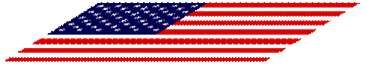
Hold flag waist-high so that it’s surface is parallel to the ground.
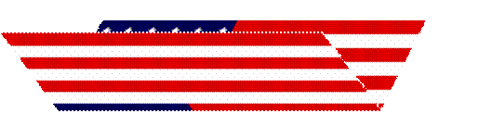
Fold the lower half of the stripe section lengthwise over the blue field.

Fold the flag again lengthwise with the blue field on the outside.

Start a triangular fold by brining the striped corner of the folded edge to the open edge.

Fold the outer point inward parallel with the open edge to form a second triangle.

Continue folding until the entire length of the flag is folded into a triangle with only the blue field and margin showing.

Tuck the remaining margin into the pocket formed by the folds at the blue field edge of the flag. The properly folded flag should resemble a cocked hat.

Pledge of Allegiance
The following is the official salute to the flag:
"I pledge allegiance to the flag of the United States of America and to the Republic for which it stands, one Nation under God, indivisible, with liberty and justice for all."
National Anthem
The Star Spangled Banner
Oh, say, can you see, by the dawn's early light,
What so proudly we hailed at the twilight's last gleaming?
Whose broad stripes and bright stars, thro' the perilous fight,
O'er the ramparts we watch'd, were so gallantly streaming?
And the rocket's red glare, the bombs bursting in air
Gave proof thro' the night that our flag was still there.
Oh, say, does that Star-Spangled Banner yet wave
O'er the land of the free and the home of the brave?
On the shore, dimly seen thro' the mists of the deep,
Where the foe's haughty host in dread silence reposes,
What is that which the breeze, o'er the towering steep,
As it fitfully blows half conceals, half discloses?
Now it catches the gleam of the morning's first beam,
In full glory reflected now shines in the stream;
'Tis the Star-Spangled Banner, O long may it wave
O'er the land of the free and the home of the brave.
Oh, thus be it ever when free men shall stand
Between their loved homes and the war's desolation!
Blest with vict'ry and peace, may the heav'n rescued land
Praise the Pow'r that hath made and preserved us a nation!
Then conquer we must, when our cause it is just,
And this be our motto, "In God is our trust"
And the Star-Spangled Banner in triumph shall wave
O'er the land of the free and the home of the brave!
The National Anthem
Condensed from an article by Isaac Asimov in the March 1991 issue of The Magazine of Fantasy and Science Fiction.
In 1812, the United States went to war with Great Britain, primarily over freedom of the seas. We were in the right and, for two years, we held off the British, even though we were still a rather weak country.
Great Britain was in a life-and-death struggle with Napoleon. In fact, just as the United States declared war, Napoleon marched off to invade Russia. If he won, as everyone expected, he would control Europe, and Great Britain would be isolated. It was no time for her to be involved in an American war.
At first, our seaman proved better than the British. After we won a battle on Lake Erie in 1813, the American commander, Admiral Oliver Hazard Perry sent the message "We have met the enemy and they are ours."
However, the weight of the British navy eventually beat down our ships. New England, hard-hit by a tightening blockade, threatened secession.
Meanwhile, Napoleon was beaten in Russia and in 1814 was forced to abdicate. Great Britain now turned its full attention to the United States, launching a three-pronged attack. The northern prong was to come down Lake Champlain toward New York and seize parts of New England. The southern prong was to go up the Mississippi, take New Orleans, and paralyze the west. The central prong was to head for the mid-Atlantic states, and then attack Baltimore, the greatest port south of New York.
If Baltimore was taken, the nation, which still hugged the Atlantic coast, could be split in two. So the fate of the United States rested to a large extent on the success or failure of the central prong.
The British reached the American coast and, on August 24, 1814, took Washington, D.C. Then they moved up the Chesapeake Bay toward Baltimore. On September 12, they arrived and found 1000 men in Fort McHenry, whose guns controlled the harbor. If the British wished to take Baltimore, they would have to take the fort.
On one of the British ships was an aged physician, William Beanes, who had been arrested in Maryland and brought along as a prisoner. Francis Scott Key, a lawyer and friend of the physician, had come to the ship to negotiate his release. The British captain was willing, but the two Americans would have to wait. It was the night of September 13, and the bombardment of Fort McHenry was about to begin.
As twilight deepened, Key and Beanes saw the American Flag flying over Fort McHenry. Through the night, they heard bombs bursting and saw the red glare of the rockets. They knew the fort was resisting and the American flag was still flying. But toward morning the bombardment ceased, and a dread silence fell. Either Fort McHenry had surrendered and the British flag flew above it, or the bombardment had failed and the American flag still flew.
As the dawn began to brighten the eastern sky, Key and Beanes stared out at the fort, trying to see which flag flew over it. He and the physician must have asked each other over and over, "Can you see the flag?"
After the battle was all finished, Key wrote a four-stanza poem telling the events of the night. Called "The Defense of Fort McHenry," it was published in newspapers and swept the nation. Someone noted that the words fit an old English tune called "To Anacreon in Heaven," a difficult melody with an uncomfortably large vocal range. For obvious reasons, Key's work became known as the "The Star-Spangled Banner," and in 1931 Congress declared it the official anthem of the United States.
Now that you know the story, here are the words. Presumably, the old doctor is speaking and this is what he asks Key:
Oh! say, can you see, by the dawn's early light,
What so proudly we hailed at the twilight's last gleaming?
Whose broad stripes and bright stars, through the perilous fight,
O'er the ramparts we watched were so gallantly streaming?
And the rocket's red glare, the bombs bursting in air,
Gave proof thro' the night that our flag was still there.
Oh! say, does that star-spangled banner yet wave
O're the land of the free and the home of the brave?
" Ramparts" are the protective walls or other elevations that surround a fort. The first stanza asks a question, the second gives an answer:
On the shore, dimly seen thro' the mist of the deep,
Where the foe's haughty host in dread silence reposes,
What is that which the breeze, o'er the towering steep,
As it fitfully blows, half conceals, half discloses?
Now it catches the gleam of the morning's first beam,
In full glory reflected, now shines on the stream:
Tis the star-spangled banner. Oh! long may it wave
O'er the land of the free and the home of the brave!
"The towering steep" is again the ramparts. The bombardment has failed, and the British can do nothing but sail away, their mission a failure. In the third stanza, Key allows himself to gloat over the American triumph, which was understandable after the bombardment he had witnessed. During World War II, when the British were our allies, this third stanza was not sung.
And where is that band who so vauntingly swore
That the havoc of war and the battle's confusion
A home and country should leave us no more?
Their blood has washed out their foul footstep's pollution.
No refuge could save the hireling and slave
From the terror of flight, or the gloom of the grave,
And the star-spangled banner in triumph doth wave
O'er the land of the free and the home of the brave
The fourth stanza, a pious hope for the future, should be sung more slowly than the other three and with even deeper feeling:
Oh! thus be it ever, when freemen shall stand
Between their loved homes and the war's desolation,
Blest with vict'ry and peace, may the Heav'n-rescued land
Praise the Pow'r that hath made and preserved us a nation.
Then conquer we must, for our cause it is just,
And this be our motto, "In God is our trust."
And the star-spangled banner in triumph doth wave
O'er the land of the free and the home of the brave.

