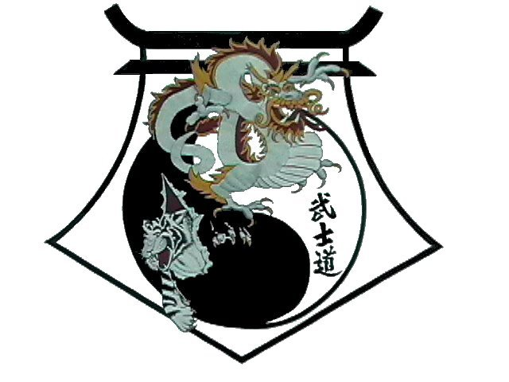
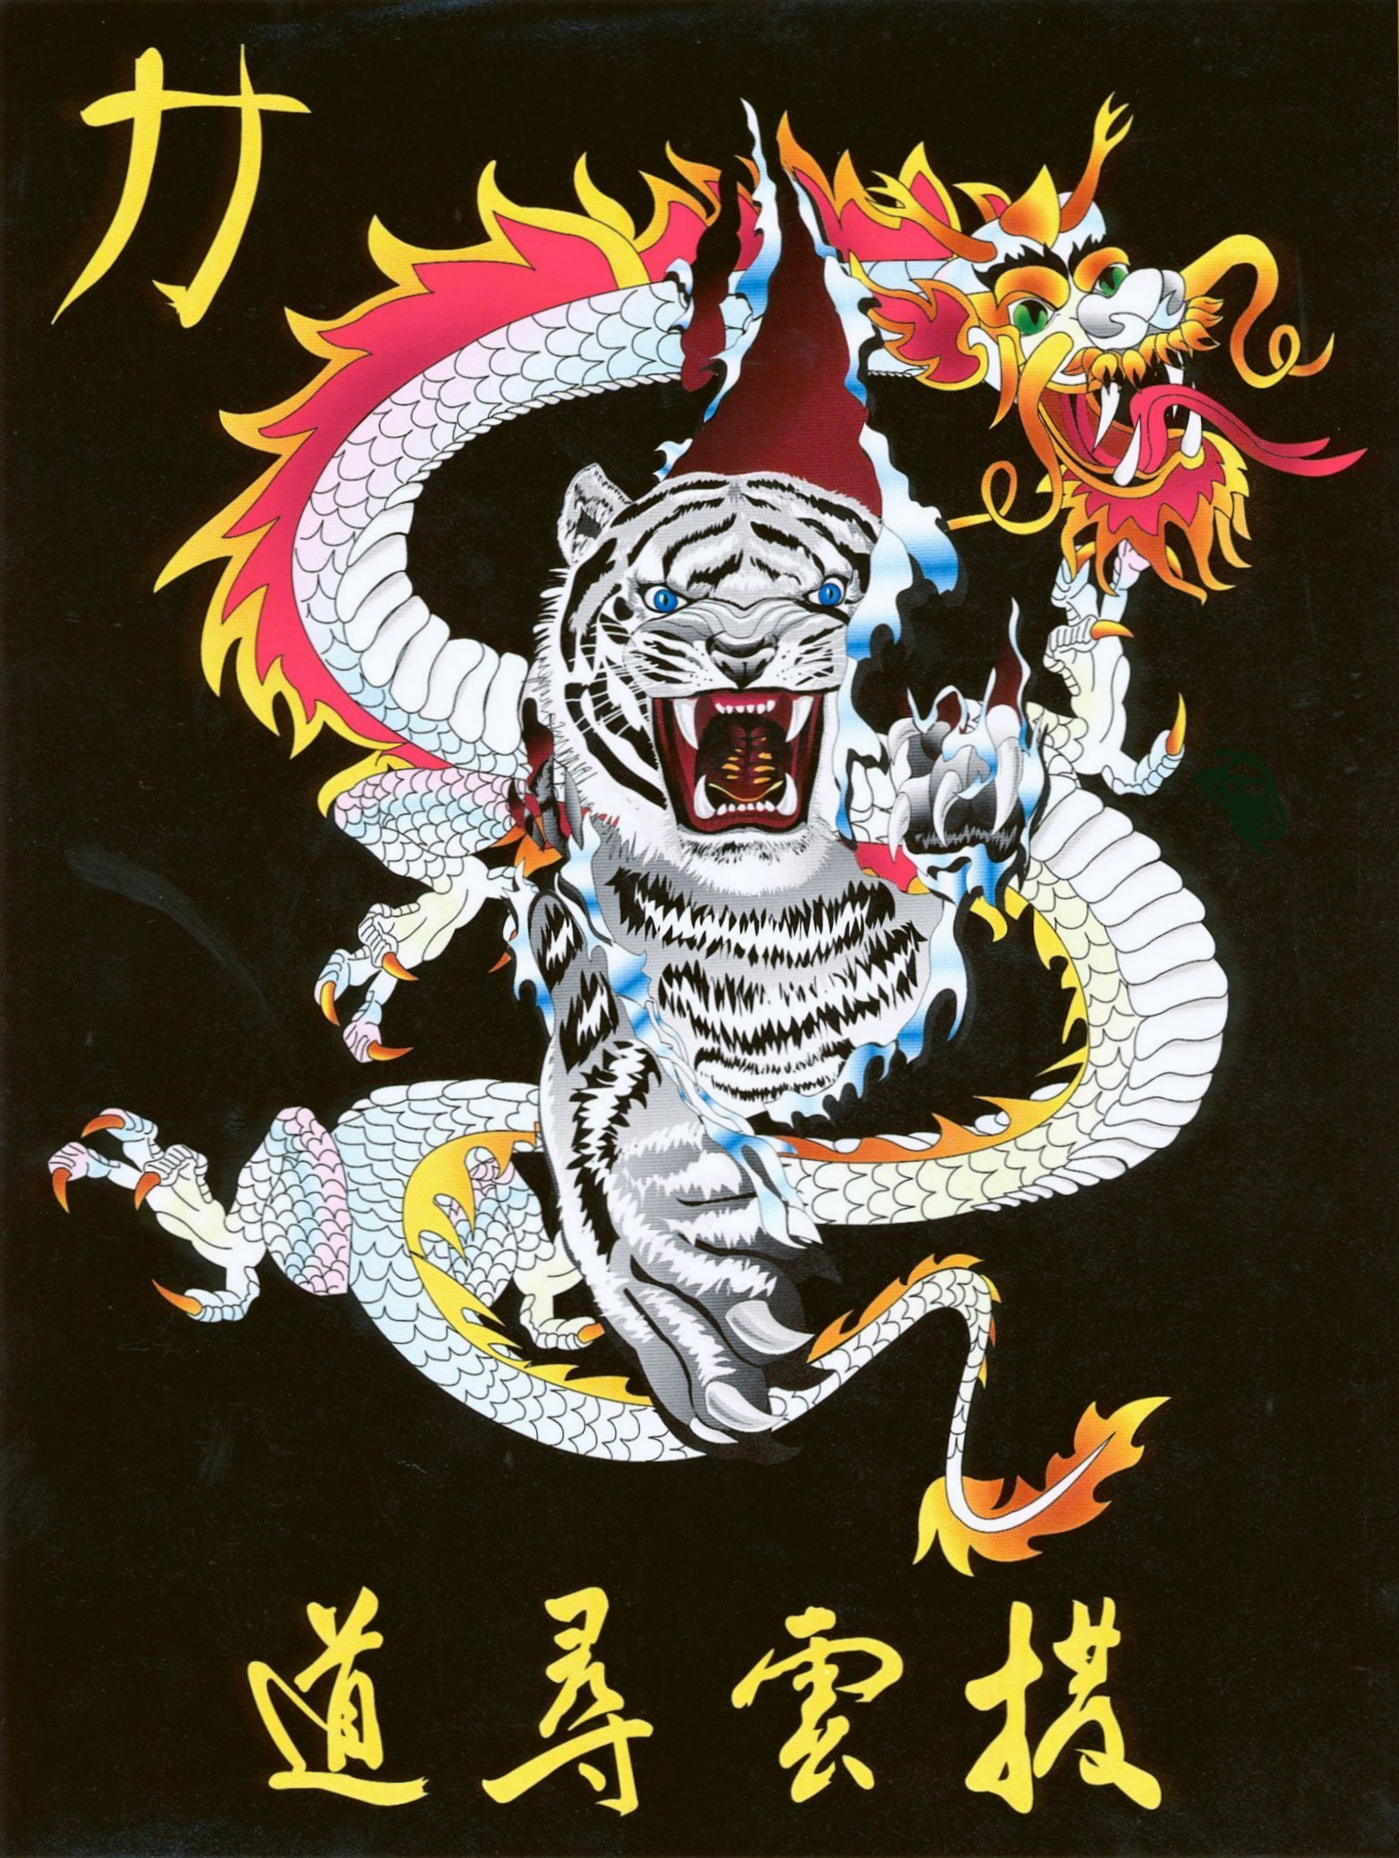
Shihan Ron Bennett’s
White Dragons of Bushido
Korean Flag

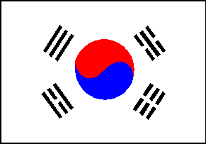

Many Taekwondo students wear the South Korean national flag (Tae-Guk) on their uniforms, see the flag in the dojang, and even bow in respect to the flag during training, without knowing about its background.
The Korean peninsula is divided into two nations, North Korea and South Korea, and each country has its own flag. The North Korean flag, and its coat of arms, have a red star on them that symbolizes communism. The coat of arms also has a power plant on it that symbolizes industry.
The Korean name for Korea is "Hangeuk" and its people are called "Hangeuksaram". The ancient name for Korea is "Choson", which means "the land of morning calm" and comes from the Choson (or Yi) Dynasty (1392-1905). The name "Korea" comes from the Koryo Dynasty (935-1392), during which westerners had their first contact with Korea.
Origin of Flag
By the end of the 19th century, Korea was under the influence of colonists such the Japanese, Chinese, and Russians, and it needed its own flag. According an article published on October 2, 1882 in the Tokyo daily newspaper, Emperor Go-jong designed the original flag, which was adopted in August 1882. The Emperor then ordered Young-Hyo Park to use the flag on his trip to Japan as a diplomat. Park used the flag again in 1887 on a trip to the United States.
The flag has been a source of pride and inspiration for Koreans as symbol of their struggle for independence and freedom. During the Japanese occupation, 1910-1945, the Japanese outlawed the flag in public places but the people kept it hidden until Liberation Day. In 1950, after the formation of the Republic of Korea, the flag was officially adopted as the flag of South Korea.


Meaning of Symbols and Colors
Eum-Yang
Objects depicted on the flag symbolize much of the thought and mysticism of oriental philosophy. The circle depicted on the flag, the eum-yang (shown on left), is divided equally and is in perfect balance. Its origin is based on the oriental philosophy of eum-yang (known in China as yin-yang). It was originally thought that this philosophy was developed in China by Chou Fung-i (1016-1073 AD), a metaphysical philosopher of the Sun Dynasty, who published his theory of tai-chi in 1070 AD and supposedly designed the tai-chi (yin-yang) symbol. However, a piece of stone with the eum-yang (yin-yang) symbol carved on it was discovered at the site of the Korean Buddhist temple Kam-Eun, which was built in 682 AD. This is the oldest known use of the eum-yang symbol. This discovery indicates that the symbol was in use in Korea as early as 682 AD, well before Chou Fung-i was born .
The eum-yang symbol expresses the dualism of the universe, the perfect harmony and balance among opposites, and the constant movement within the sphere of infinity. An example of dualism may be expressed in the upbringing of a child. There are two opposing methods to raise a child: praise or punishment. Praise is considered good and punishment is considered bad, but both are needed for a proper upbringing. However, too much of either may cause behavior problems with the child. There must be balance and harmony between the two extremes to ensure the child is brought up properly.
Eum (blue portion of the symbol) means dark, cold, or negative, while yang (red portion of the symbol) means bright, hot, or positive. A very old Chinese book called Choo-Yuk claims that all objects, through the movement of yin (eum) and yang, express events by their dualism. For example, the moon is eum, the sun is yang; the earth is eum, the sky is yang; night is eum, the day is yang; and the winter is eum, the summer is yang. Eum and yang are relative. Therefore, "A" can be eum with respect to "B" while being yang with respect to "C." For example, the spring is eum to the summer yang while also being yang to the winter eum. Eum and yang compliment each other. Neither exists of itself alone, they must exist together. To appreciate beauty, you must have ugliness. What benefit is good (yang) if evil (eum) does not exist?
Lao Tsu (known No Ja in Korea), a famous Chinese philosopher who founded Taoism, wrote a chapter on dualism in his book Tao Te Ching. The following is a summary of the chapter:
Under heaven all may see beauty as beauty only because there is ugliness.
All may know good as good only because there is evil.
Therefore having and not having arise together.
Difficult and easy complement each other.
Long and short contrast each other.
Front and back follow one another.
Therefore, the sage goes about doing nothing, teaching no talking.
The ten thousand things rise and fall without cease,
Creating, not possessing,
Working, yet not taking credit.
Work is done, then forgotten,
Therefore it lasts forever!
When looking at the two comma-shaped sections "ukwdrops" in the eum-yang symbol, the thicker part of a section indicates the beginning and the slender part indicates the end. The eum begins where the yang gradually vanishes and vice versa. The red section is always on the top half of the circle.
The harmonious state of the movement of eum-yang is called tae-guk in Korean (tai- chi in Chinese). In Korea, the flag itself, is called Tae-Guk (the origin of all things in the universe) or Tae-Guk-Ki ( ki means flag). Tae-Guk is also known as the flag of "great extremes."

Trigrams
While the circle represents dualism, the four trigrams at the corners of the flag (called "gwe" in Korean) represent the four points of the compass, the concept of opposites and balance, and the government. The book of I Ching (Book of Changes), called Yeok in Korean, illustrates 64 trigrams, but the four used on the flag represent the essence of the Dao philosophy of the complete circle of life. Western people are probably familiar with the concept of Karma, or "What goes around comes around." Both Dao and Confucianism thought the family was the center of society. The family, and ones role in the family, determine ones position and role in society.
The two upper trigrams on the flag are "heaven" and "earth." They are at the top because they represent the head of the family. Without them, there is no family. Without the family, there is no society. The lower two trigrams are "water" , and "fire." Together the four trigrams express the mysteries of the universe, but they also represent father, mother, daughter, and son. Confucianism thought these four elements made the perfect family. A family with these four parts had perfect balance (eum-yang). The symbols are placed in a circle to represent the circle of life (the endless cycle of birth, death, and rebirth) and the continuing nature of the universe.
  Kun |  |   Kam
  Yi |  |   Kon
 Kun
Location: Upper left
Name: Heaven
Season: Spring
Direction: South
Family: Father
Known as: The creative one
Represents: Represents bright sunshine when the sun is in the South and its light that makes things grow.
Meaning: All three lines in the trigram are solid representing the completeness of life. As heaven is greater than the earth, this trigram is first on the flag. The fathers concern for his family is greater than just earthly survival.
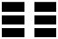 Kon
Location: Lower right
Name: Earth
Season: Summer
Direction: North
Family: Mother
Known as: The receptive one
Represents: Represents total darkness when the sun is in the North.
Meaning: Earth and mothers are the source of life. The top and bottom line of the trigram are open indicating a mother's receptiveness and the incompleteness of life on earth. The center is filled representing the completeness and perfection of motherhood.. The role of the the mother is to provide for the earthly necessities of life. The top and bottom lines are open representing openness.

 Yi
Location: Lower left
Name: Fire
Season: Autumn
Direction: East
Family: Son
Known as: The persisting one
Represents: Represents fire that gives warmth and light, and dawn and early sunlight as the sun rises in the East.
Meaning: Trigram is closed at the top and bottom, showing that a son must be well grounded in the heavenly and scholarly ways for his coming role as the father of his family. The center line is open because the son has not yet fathered a child and he so is viewed as incomplete.

 Kam
Location: Upper right
Name: Water
Season: Winter
Direction: West
Family: Daughter
Known as: The abysmal one
Represents: Represents twilight as the sun sets to the West and water, which has no shape or form.
Meaning: The trigram is completely open. The center is open because she is not yet viewed as fertile, because she has bore no children. The top and bottom are open to represent her coming role as the provider of earthly necessities for her future family. As water flows, when she marries, she will flow out of one family and into another.
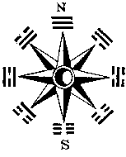
The I Ching illustrates the same trigram layout that is depicted on the flag. It shows the eum-yang symbol in the center and trigrams on the sides, but it shows eight trigrams. The other trigrams are "mountain" and "lake", and "thunder" and "wind." Each of the trigrams have a special meaning and is either eum or yang. Heaven and lake are major yangs; water and wind are minor yangs. Earth and mountain are major eums; thunder and fire are minor eums. Originally there were only five trigrams, one for each of the five elements: water, metal, fire, wood, and earth. They were arranged like a compass, with earth in the center, metal on the left, wood on the right, water at the top, and fire at the bottom.
Colors
The white background color of the flag represents the land, the purity of the Korean people, and their peace-loving spirit. Korean people have preferred to wear white clothing, hence, Korea has been called the "white-clad" nation. The eum-yang circle represents the people; the red upper half (yang) represents male and the blue lower half (eum) represents female. Yellow (gold)
During the Yi Dynasty, official buildings were painted in specific color schemes to denote the social position of the occupant or his office. One color scheme was reserved for the royal class of society "Yang Bang". Unlike western royalty, which is primarily determined by birth, Yi society permitted a lower class person to advance in class through a series of civil servant exams. This insured that the brightest would be the leaders, regardless of their birth status. When the colors of the Korean flag were chosen, the color scheme of the Yang Bang was used, symbolizing the elevation of all Korean people to the level of the royal class. This concept of a democratic society where all were equal was an idea the Japanese opposed, which increased their opposition to the flag during their occupation of Korea.
Korea, 1893 | Royal Korean Consulate in Hamburg 1893
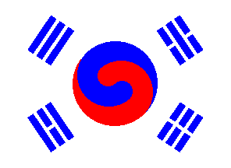 | 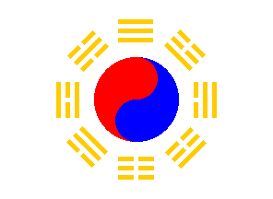
Other Korean National Symbols
National Anthem
The national anthem of Korea, Aeguk Ka (love of country), was written during the Japanese occupation of Korea (1905-1945) and was later set to music by Ahn Eak Tai.
Dong Hae Mul Gwa Paek To San
I Ma Ru Go Dal T'o Rok,
Ha Nu Nim I Bo U-Ha Sa
U Ri Na Ra Man Se,
Mu-Gung Hwa Sam-Ch'ol
Li HwaryoGang- San,
Dae Han Sa Ram Dae Han-U
Ro Ki Ri Bo Chon Ha Se.
------------------------------------------------------------------------
Until the East Sea's waves are dry, (and)
Mount Paektusan worn away, God watch o'er our land forever!
Our Korea manse!
Refrain
Rose of Sharon, thousand miles of range and river land!
Guarded by her people, ever may Korea stand!
Like Mount Namsan armored pine, standing on duty still,
wind or frost, unchanging ever,
be our resolute will.
In autumn's arching evening sky, crystal, and cloudless blue,
Be the radiant moon our spirit,
steadfast, single and true.
With such a will, (and) such a spirit, loyalty, heart and hand,
Let us love, come grief, come gladness,
this our beloved land!

National Flower
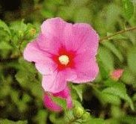 | The Rose of Sharon (Hibiscus Syriacus L.) is generally accepted as the national flower of Korea due to its popularity among the Korean people. They call it mugunghwa, the "flower of eternity," since it embodies their aspiration for eternal prosperity.
National Emblem
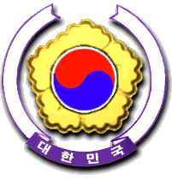 | The Korean emblem was established by Cabinet Decree No. 1671 on December 10, 1963. It is used on official documents dispatched to foreign countries and other important government papers.
KOREAN CUSTOMS
Major Korean Celebrations
New Year's Day: Seol Nal (January 1 by Lunar Calendar)
Upon waking early in the morning, first greet elder family members, starting with the eldest male family member, with the formal "Big Bow". Next visit all relatives throughout the town, greeting them formally in the same order, starting with closer relatives, wishing them all "health and happiness through the year". After greeting all relatives, many may visit someone they respect, such as school teachers, town officials, and members of friends' families.
This type of greeting is everyone's moral duty on New Year's Day. When the young greet the elders, the elders give "bok don" (fortune money, a token of love) to the young. This is the traditional way of returning something back to the young people for sharing their appreciation to the elders for what the elders have done for them. It is not a large amount of money, sometimes only a few cents, but it is given with great feeling.
After greeting relatives and others that you respect, it is time to eat. All day long, people will fly kites or play "Jae Ki Chagi," kicking game played with an object made with a coin and rice paper (similar to "Hacky-Sack"). One of the interesting games that all the family can enjoy is "Yoot Nohl Ee". A small log, measuring one inch in diameter and six to seven inches long, is cut in half, both through the width and length, so that you have four pieces with one side curved and one side flat. Then, taking turns, each person picks up the pieces and drops them on the floor, and each pattern they make has a different meaning.
January 15: Chung Wol Dae Bolum (Lunar Calendar) (The First Great Full Moon of the Year)
On this day, parents will tell stories to their children. For example, they will tell their children to stay awake all night, or their eyebrows will turn white. During the evening, most of the townspeople play a kind of "war game." In Korea, most towns are near mountains, and the houses are built with the front door facing away from the mountains. On this day, each town builds a big fire right in front of the town. The wood for the fire is built up like a big bed, and then set on fire. This is called "Mo Dak Bool." Because of the fires, all the towns are visible. Then all the participants each get a small can, punch many holes in it, and stuff it with many pieces of wood that are very easy to ignite and that will burn for a long time. This can is then attached to a long handle, and the can is swung round and round. All of the young people in town do this, and it looks very beautiful from far away. Then each town will try to invade the other towns. When they meet in the middle, they "fight" and try to gather up their opponents fire cans, and go on to the next enemy town to take the fire from that towns fire, and win the game.
This day teaches the children teamwork and to be responsible for their family, and also that it is their duty to defend their family. It also teaches patience, by overcoming the difficulty of staying awake all night.
August 15: Choo Seok (Lunar Calendar)
Similar to the American Thanksgiving holiday, this day is a time of the first rice harvest. On the night before, people set out different types of food: fish, meat, vegetables, fruit, etc., pretending that it is for the departed souls of ancestors to eat. then, at about 4 or 5 o'clock a.m. on the 15th, when the roosters cry, it is a signal for the departed souls to leave and for the family to get together and eat the same food that was set out for the ancestors. Everyone then rests for two to three hours, then wakes up, cleans up, and goes to visit their ancestors' cemetery. They first visit the fourth or fifth oldest generation, and then the more recent ones. Even though each ancestor still has an anniversary once a year, this is a very important holiday in Korea because the whole family can enjoy being together to honor their ancestors.

Religious Holidays

April 8: Buddha's Birthday
Everyone goes to a Buddhist temple and lights a candle with their name and a message to the Buddha. Most people
celebrate his birthday even if they are not Buddhist.
December 25: Christ's Birthday
Same as in the United States. Most people celebrate even if they are not Christian. In Korea, there is not as much gift giving as in the United States.
Individual Celebrations
First 100 days Party
In the old days many people died before they were born, or before their first 100 days of life. So, someone who lived past the 100-day mark could be expected to live a full life. This day is really more a "welcoming" day than a birthday and is now a tradition.
First Year Birthday
Similar to the 100-day celebration. So many people died before their first year of life, so if they reached one year, they were most likely to continue to live a normal life span.
60th and 70th Birthdays
Same as above. If someone lives to age 60, or especially 70, we celebrate their having such a long life.

Relationships

Weddings
A lifetime event. When two people get married, they are bound until they die. For better or worse, no matter what happens to the other spouse, they will stick together. Two people are usually married by the parent's decision. When the age for marriage is reached, parents will look for a match. They will try to find out the personal background, personality, past generational background, and everything possible about the future spouse. Sometimes, if parents know the other family well, they may choose a spouse even before there child is born. If the parents don't know anyone, then they will use a matchmaker to find a spouse. Marriages of this type are traditional and rarely ever break up.

Etiquette
Most follow the phrase "Sang Kyeong Ha Yae" which means respect your elders and love your juniors all the time. Whenever meeting an elder, always show politeness and speak to him/her properly with care, concern, and full concentration. Seniors show care and loving to juniors by fully supporting them to be a better person and success in life while always correcting and teaching their mistakes with love. This develops self-respect and makes good etiquette a habit, so that whenever one does something, one really cares about what he/she is doing.
Own Family
Usually the eldest son (and his family if he already ahs one) lives with his parents. So, if the father was the eldest son, the eldest son will also be living with his grandparents. Normally the grandfather commands and has control over the family. If a son lives only with his wife and children, heam in charge. If he dies and the wife is still alive, and the eldest son is old enough, he will take responsibility for the family. If he is not old enough, then the oldest person, the wife, will take the responsibility for the family. Men are called "outsiders." Women are called "insiders." The woman is responsible for the needs of housekeeping, the whole family, and maintaining happiness and peace. The man works outside and fights for whatever necessities the family needs, for success and better living.

For Older Persons
If the older person is known, call him/her by the family name or title. But if they are friends of the family, call all their family members as you would call your own family members, for example, older brother, older sister, uncle, aunt, etc. Call younger people by their first and middle names. If you don't know the older person, call a man "Sun Seng Nim" (sir) or "Ah Jeo See" (uncle), and a woman "Ah Ju Muh Knee" (aunt). Senior citizens are called "Hal Ah Buh Jee" (grandfather) and "Hal Muh Knee" (grandmother).
Teacher and Student
The teacher receives respect from the student and gives student love. The teacher/student relationship is similar to the relationship between parent and child, no matter what the ages of the teacher and the student.
Community Leaders
Community leaders are shown the same respect as is shown to teachers. We respect them as our leaders no matter what their age. They love the community and have responsibility for it.

